Project - High Level Design
on
IaC Provisioning for Real Estate System
Course Name: DevOps Foundations

Institution Name: Medicaps University – Datagami Skill Based Course

Student Name(s) & Enrolment Number(s):
Sr no | Student Name | Enrolment Number
1. | Vidhi Yadav | EN22CS3011077
2. | Suhani Pathak | EN22CS301990
3. | Surbhi Jadam | EN22CS3011002
4. | Vanshika Soni | EN22CS3011061
5. | Vinay | EN22CS3011082

Group Name: D9 Group 07
Project Number: 07
Industry Mentor Name: Mr.Vaibhav
University Mentor Name: Dr. Ritesh Joshi
Academic Year: 2025 - 2026

Table of Contents
- Introduction.
  - Scope of the document.
  - Intended Audience
  - System overview.
- System Design.
  - Application Design
  - Process Flow.
  - Information Flow.
  - Components Design
  - Key Design Considerations
  - API Catalogue.
- Data Design.
  - Data Model
  - Data Access Mechanism
  - Data Retention Policies
  - Data Migration
- Interfaces
- State and Session Management
- Caching
- Non-Functional Requirements
  - Security Aspects
  - Performance Aspects
- References

1. Introduction
This High-Level Design (HLD) document describes the architecture and design of the IaC Provisioning for Real Estate System. The project automates the provisioning and deployment of infrastructure for a Real Estate web application using Infrastructure as Code (IaC) tools, Docker, CI/CD pipelines, and Kubernetes. The application is built on a React (Vite) frontend, a Python-based backend API (Flask/FastAPI), and a MySQL relational database.

1.1 Scope of the Document
This document covers the high-level architectural design of the IaC provisioning system including:
- Infrastructure provisioning design using Terraform and Ansible
- Containerization strategy for the application (React frontend, Python backend, MySQL database)
- CI/CD pipeline architecture using Jenkins
- Kubernetes orchestration design for container management
- Data design and API catalogue for the Real Estate application
- Security, performance, and non-functional requirement considerations

1.2 Intended Audience
This document is intended for the following audiences:

Audience | Role | Purpose
Development Team | Developers / Engineers | Understand system architecture and implementation guidelines
DevOps Engineers | Infrastructure & Pipeline | Implement and maintain IaC scripts, CI/CD, and Kubernetes
University Mentor | Prof. Riteish Joshi | Review and evaluate the technical design
Project Evaluators | Datagami / Medicaps | Assess project completeness and quality
System Administrators | IT Operations | Understand deployment and maintenance procedures

1.3 System Overview
The IaC Provisioning for Real Estate System is a fully automated DevOps pipeline built to provision, containerize, and deploy a Real Estate web application. The system addresses the challenge of manual, error-prone infrastructure setup by automating all stages from code commit to live deployment.

The system consists of five major layers:
- Application Layer: React (Vite) frontend, Python (Flask/FastAPI) REST API backend, MySQL relational database
- Containerization Layer: Docker and Docker Compose for packaging each application component into isolated containers
- CI/CD Layer: GitHub Actions / Jenkins pipeline for automated build, test, and deployment
- Infrastructure Layer: Terraform / Ansible for automated cloud resource provisioning on AWS
- Orchestration Layer: Kubernetes for container management, scaling, and high availability

2. System Design

2.1 Application Design
The Real Estate application is built using a React + Python + MySQL stack following a three-tier architecture. The system supports two primary user roles: Users (property searchers) and Admins (property managers). The Python backend exposes a REST API consumed by the React frontend, with MySQL serving as the persistent relational data store.

Overall System Architecture Diagram:

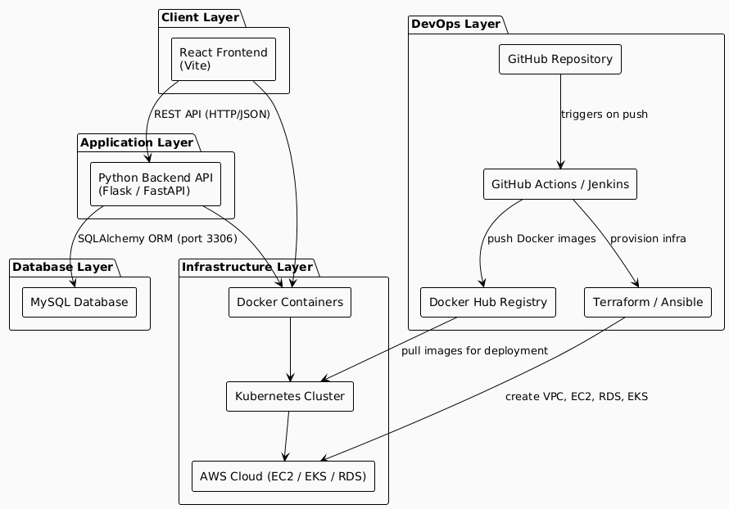
Overall System Architecture

2.2 Process Flow
The end-to-end process flow covers the developer's code commit all the way to the deployed application accessible to end users. Jenkins acts as the central orchestrator of this automated pipeline.
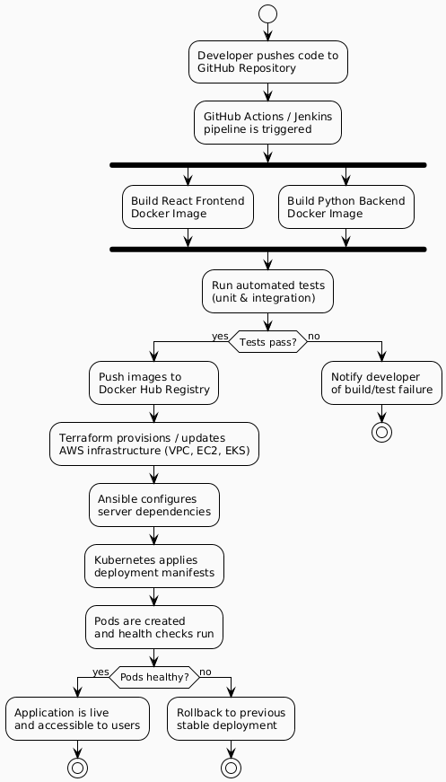
CI/CD Process Flow

2.3 Information Flow
The information flow diagram shows how data moves between the user, the React frontend, the Python backend API, and the MySQL database for both User and Admin roles.
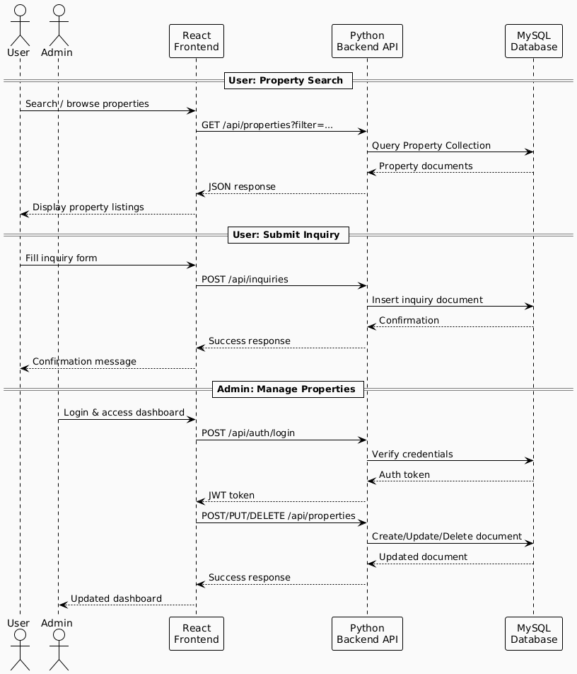
Information Flow Diagram

2.4 Components Design
The system is composed of distinct components each with a defined responsibility. The component diagram below shows how the frontend, backend, database, and infrastructure layers interact.

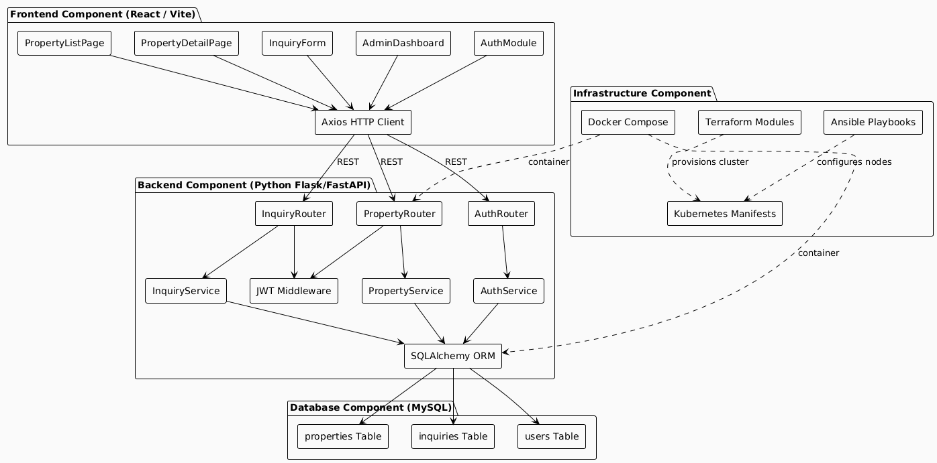
Component Design Diagram

2.5 Key Design Considerations
The following key design principles and considerations have guided the architectural decisions for this project:

Design Consideration | Description | Implementation Approach
Immutable Infrastructure | Infrastructure is versioned and fully reproducible | Terraform state management; all resources defined as code in Git
Stateless Application Containers | Containers carry no persistent state; enables horizontal scaling | MySQL external to app pods (AWS RDS); JWT for stateless auth
Automated Rollback | Failed deployments automatically revert to the last stable state | Kubernetes rolling update strategy with readiness/liveness probes
Environment Parity | Dev, Test, and Prod environments are consistent | Docker images guarantee identical runtime regardless of host
Secret Management | Credentials must never be hardcoded in code or images | Kubernetes Secrets; environment variables injected via CI/CD
High Availability | System must tolerate individual pod/node failures | Kubernetes ReplicaSets with minimum 2 replicas per service
Database Reliability | MySQL data must persist and be recoverable | AWS RDS managed MySQL with automated backups and Multi-AZ

2.6 API Catalogue
The Python backend exposes a RESTful API consumed by the React frontend. All responses are in JSON format. Protected endpoints require a valid JWT in the Authorization header.

Method | Endpoint | Description | Auth Required
GET | /api/properties | Retrieve all properties (supports filters: location, type, price) | No
GET | /api/properties/{id} | Retrieve a single property by ID | No
POST | /api/properties | Create a new property listing | Yes (Admin)
PUT | /api/properties/{id} | Update an existing property | Yes (Admin)
DELETE | /api/properties/{id} | Delete a property listing | Yes (Admin)
POST | /api/inquiries | Submit a property inquiry | No
GET | /api/inquiries | Get all inquiries | Yes (Admin)
GET | /api/inquiries/{id} | Get a specific inquiry's details | Yes (Admin)
PUT | /api/inquiries/{id} | Update inquiry status (new/resolved) | Yes (Admin)
POST | /api/auth/register | Register a new user account | No
POST | /api/auth/login | Authenticate user and return JWT | No
GET | /api/auth/me | Get current authenticated user profile | Yes (User)

3. Data Design

3.1 Data Model
The application uses MySQL as its relational database. SQLAlchemy is used as the ORM layer in Python. The schema consists of three primary tables: properties, inquiries, and users, with proper foreign key relationships enforced at the database level.
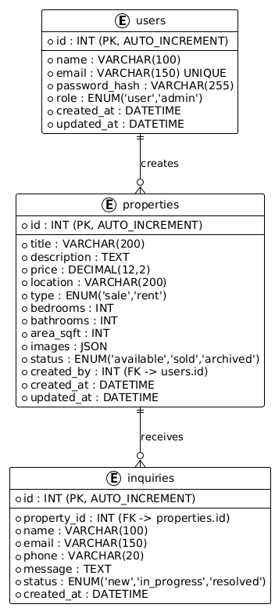
Entity Relationship Diagram (MySQL Schema)

3.2 Data Access Mechanism

Data access follows a layered pattern within the Python backend. SQLAlchemy ORM is used for all database interactions, providing abstraction from raw SQL and enabling easy schema evolution via Alembic migrations.

Layer | Technology | Responsibility
Router Layer | Flask Blueprints / FastAPI Routers | Parse HTTP requests, validate inputs (Pydantic/Marshmallow), call service layer
Service Layer | Python Service Classes | Implement business logic; orchestrate ORM calls; handle transactions
ORM Layer | SQLAlchemy (with Alembic migrations) | Map Python models to MySQL tables; manage connections and sessions
Database Layer | MySQL (AWS RDS) | Store and retrieve relational data; enforce constraints and indexes

Database indexes applied for query performance: index on properties(location), properties(type, status), properties(price), and inquiries(property_id). Composite index on properties(type, status, price) for filtered listing queries.

3.3 Data Retention Policies
The following data retention policies apply to the system:

Data Type | Retention Period | Archival / Deletion Strategy
Active Property Listings | Indefinite (while status = available) | Soft delete: status updated to 'archived'; hard delete by admin only
Resolved Inquiries | 12 months | Status set to 'resolved'; auto-archived after 12 months via scheduled job
User Accounts | Indefinite (while active) | Soft delete via is_active flag; admin can permanently purge
Application Logs | 30 days | Container log rotation via AWS CloudWatch Logs with 30-day retention
CI/CD Build Artifacts | 7 days | Auto-cleaned by GitHub Actions artifact retention policy
MySQL Automated Backups | 7 days (RDS default) | AWS RDS automated daily snapshots; point-in-time recovery enabled

3.4 Data Migration

- Database schema migrations are managed via Alembic (SQLAlchemy migration tool). All migration scripts are versioned and stored in the /migrations directory of the Git repository.
- Initial schema creation is executed as a Kubernetes Init Container (or Job) on first deployment using alembic upgrade head.
- Seed data (sample property listings) is loaded via a Python seed script executed as a Kubernetes Job after initial migration.
- AWS RDS managed MySQL is used in production, providing automated backups, point-in-time recovery, and Multi-AZ failover without manual DBA intervention.
- Docker volume mounts (local/dev) and Kubernetes Persistent Volume Claims (PVC) on EBS are used only for local MySQL; production always uses RDS.

4. Interfaces
The system exposes and consumes the following interfaces:

Interface Type | Description | Technology / Protocol
User Web Interface | Browser-based frontend for property search and inquiry submission | React (Vite), served via Nginx container over HTTPS
Admin Web Interface | Dashboard for managing property listings and viewing inquiries | React (Vite) – role-based view controlled by JWT role claim
Backend REST API | Primary interface between React frontend and Python backend | HTTP/HTTPS, JSON payloads, Flask/FastAPI on port 8000
Database Interface | Python backend to MySQL communication via SQLAlchemy | TCP port 3306 (internal cluster network); AWS RDS endpoint in production
Docker Hub Interface | CI/CD pipeline pushes and Kubernetes pulls container images | Docker Registry API over HTTPS
Kubernetes API Interface | CI/CD pipeline applies manifests; operators manage cluster state | Kubernetes REST API (port 6443)
Terraform / AWS Interface | Terraform communicates with AWS to provision VPC, EC2, EKS, RDS | AWS SDK via Terraform AWS Provider over HTTPS

5. State and Session Management
The application uses a stateless authentication model based on JSON Web Tokens (JWT). The Python backend generates and validates JWTs; no server-side session store is used, keeping the backend horizontally scalable.
- Upon successful POST /api/auth/login, the Python backend verifies the hashed password (bcrypt) against the users table in MySQL and returns a signed JWT.
- The JWT payload contains the user's id and role (user or admin). It is signed with a secret key stored as a Kubernetes Secret.
- The React frontend stores the JWT in memory or a secure HttpOnly cookie and includes it in the Authorization: Bearer <token> header on all protected API requests.
- The Python backend middleware (Flask decorator / FastAPI dependency) validates the JWT signature and expiry on every
protected route before processing the request.
- Tokens expire after 24 hours. Refresh token support is identified as a future enhancement.

Aspect | Design Decision
Authentication Method | JWT (JSON Web Token) – stateless, no server-side session store
Password Hashing | bcrypt via passlib (Python) – salted hashes stored in MySQL
Token Storage (Client) | HttpOnly cookie recommended for production; in-memory for development
Token Expiry | 24 hours (configurable via JWT_EXPIRY environment variable)
Token Refresh | Re-login required on expiry (refresh token mechanism in future scope)
Frontend State | React Context API (useState/useContext) for auth state; no Redux needed at this scale

6. Caching
The following caching strategies are applied to improve performance and reduce database load:

Cache Type | Layer | Description | Technology
Browser Caching | Client | Static assets (JS bundles, CSS, images) served with long cache TTL | Cache-Control headers set by Nginx (max-age=31536000 for hashed assets)
API Response Caching | Backend (Python) | Frequently read property listings cached to avoid repeated MySQL queries | In-memory dict cache or Redis (future scope) via Flask-Caching
Database Query Cache | MySQL | MySQL query cache for repeated identical SELECT queries | MySQL query_cache (or ProxySQL in advanced setup)
Docker Layer Caching | CI/CD Pipeline | Docker build layers cached between pipeline runs to speed up image builds | GitHub Actions cache action with Docker BuildKit
DNS Caching | Infrastructure | AWS Route 53 DNS TTL reduces lookup latency for the application domain | AWS Route 53 (TTL: 300s)

7. Non-Functional Requirements

7.1 Security Aspects
The following security measures are implemented across the system:

Security Concern | Mitigation Strategy
Authentication | JWT-based authentication with bcrypt password hashing; HTTPS enforced on all endpoints via Nginx ingress with TLS
Authorization | Role-based access control (RBAC) enforced in Python middleware – Admin vs User roles checked on every protected route
Secrets Management | No hardcoded credentials; all secrets (DB password, JWT secret, AWS keys) stored in Kubernetes Secrets and CI/CD environment variables
Container Security | Official Python-slim and Node-alpine base images; containers run as non-root user; image scanning with Trivy (future scope)
Network Security | AWS Security Groups restrict inbound to ports 80/443 only; inter-pod traffic via Kubernetes NetworkPolicies; MySQL RDS not publicly accessible
Data in Transit | TLS/HTTPS via Nginx ingress controller with Let's Encrypt certificates; MySQL connections over SSL
Input Validation | Pydantic (FastAPI) or Marshmallow (Flask) for strict schema validation; React frontend validates before submission

7.2 Performance Aspects
The following performance targets and strategies are defined for the system:

Performance Metric | Target | Strategy
API Response Time | < 200ms (p95) | MySQL indexing on queried fields; SQLAlchemy connection pooling (pool_size=10)
Frontend Load Time | < 3 seconds (initial load) | Vite production build with tree-shaking, code splitting, and Nginx gzip compression
Container Startup Time | < 30 seconds | Python-slim Docker images; pre-built virtual environments baked into image
Deployment Pipeline Duration | < 10 minutes (end-to-end) | Docker layer caching; parallel frontend and backend build jobs in CI/CD
Scalability | 500+ concurrent users | Kubernetes HPA scales Python backend pods based on CPU and memory metrics
Database Performance | < 50ms query time | Composite indexes on properties(type, status, price); RDS read replicas for future scale
Availability | 99.9% uptime (SLO) | Kubernetes ReplicaSet (min 2 replicas); rolling deployment; AWS RDS Multi-AZ for DB HA

8. Project Screenshots

The following screenshots illustrate key stages of the deployed Real Estate system and the DevOps pipeline. Replace each placeholder below with the actual screenshot by inserting an image in its place.

8.1 Home Page



8.2 Property Detail Page


8.3 Contact Page
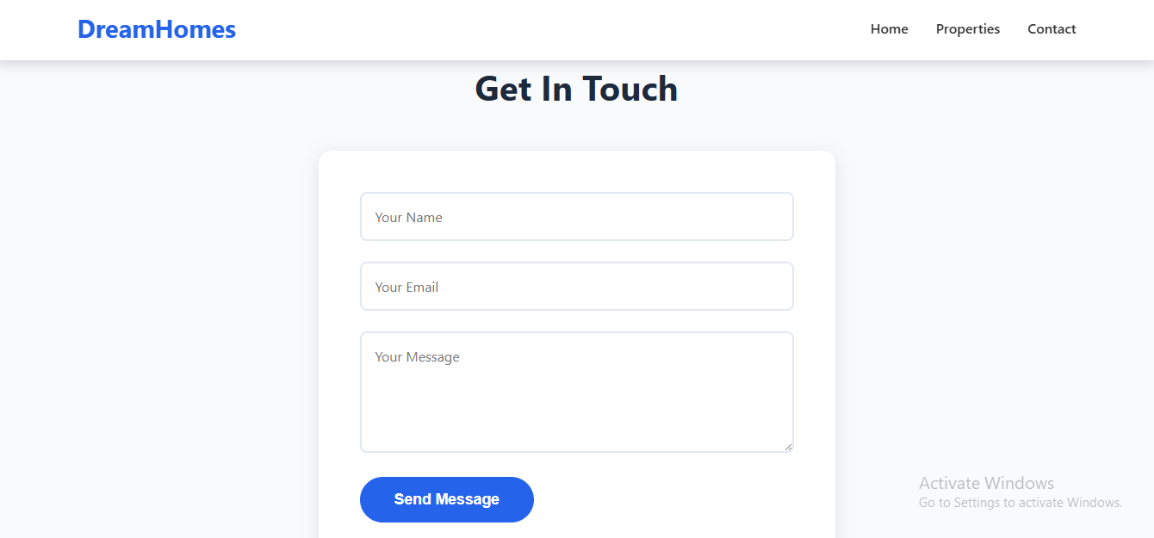

9. References
Reference | Description | Source
Terraform AWS Provider | Official HashiCorp Terraform documentation for AWS resource provisioning | https://registry.terraform.io/providers/hashicorp/aws
Ansible Documentation | Official Red Hat Ansible documentation for configuration management | https://docs.ansible.com
Docker Documentation | Official Docker containerization and Docker Compose documentation | https://docs.docker.com
Kubernetes Documentation | Official Kubernetes orchestration and manifest documentation | https://kubernetes.io/docs
Flask Documentation | Official Python Flask web framework documentation | https://flask.palletsprojects.com
FastAPI Documentation | Official FastAPI high-performance Python API framework documentation | https://fastapi.tiangolo.com
SQLAlchemy Documentation | Python ORM and Alembic migration documentation | https://docs.sqlalchemy.org
MySQL Documentation | Official MySQL 8.0 reference manual | https://dev.mysql.com/doc
React / Vite Documentation | Official React and Vite build tool documentation | https://react.dev / https://vitejs.dev
AWS Documentation | Amazon Web Services EC2, EKS, RDS, VPC | https://docs.aws.amazon.com

